DevOps Lab Report
2025

Lab Experiment – 8

Name: Saksham Maggu
SapID: 500107116
Roll No: R2142220625
Program: B.Tech. CSE [Full Stack-AI]
Semester: 6
Batch: Batch2 (Non-Hons)


School of Computer Science
UPES, Dehradun

Exp: Setting up a WordPress Site using Docker Compose

- Set Up the WordPress Project Directory
- Create the Docker Compose YAML File

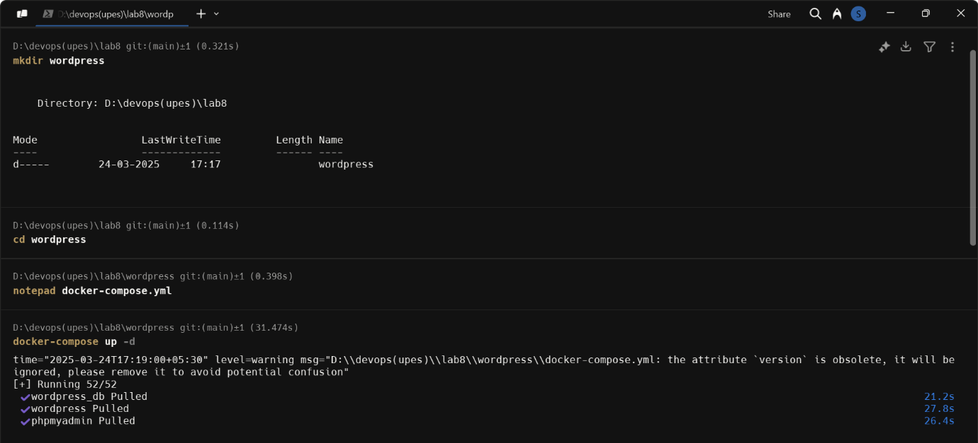
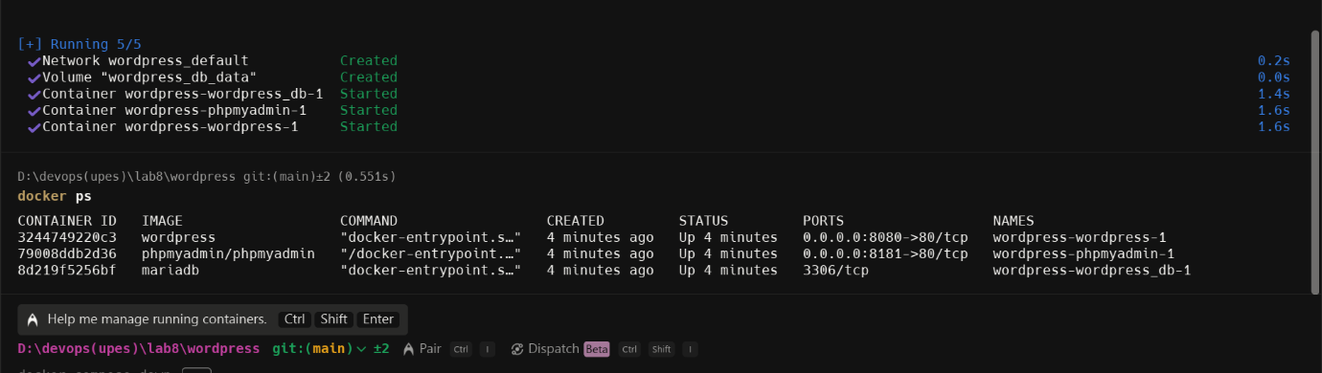
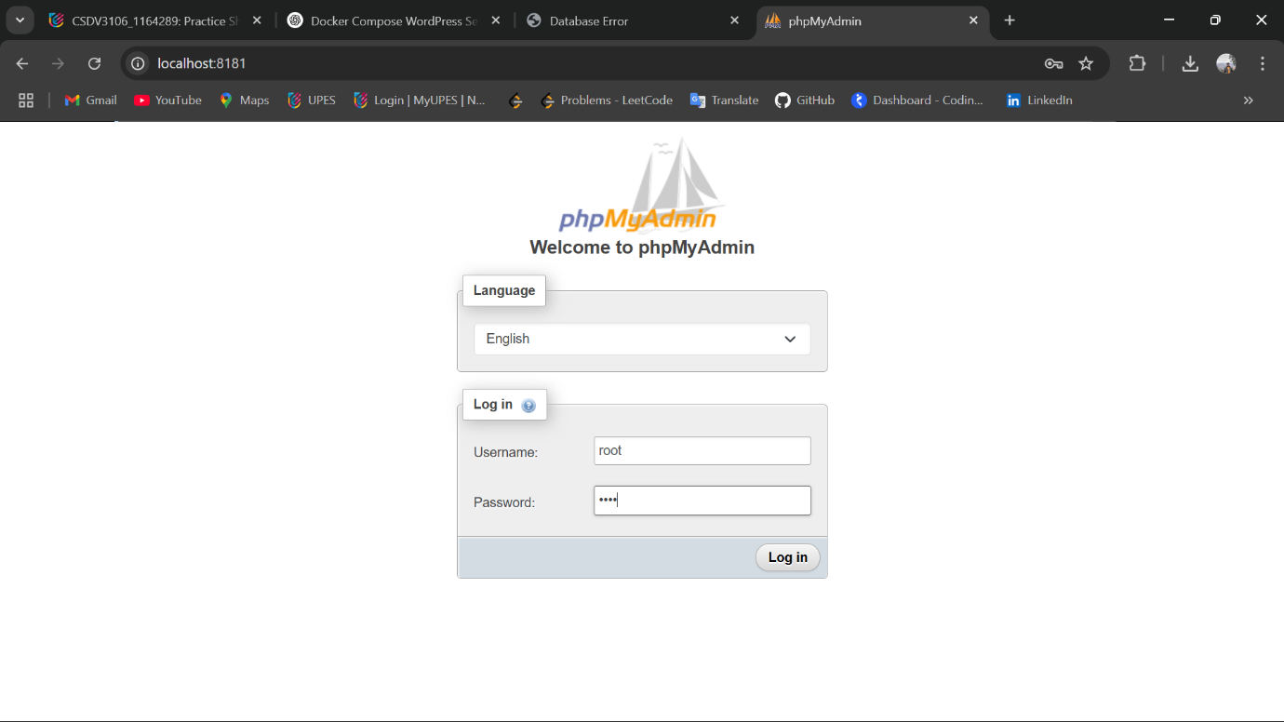
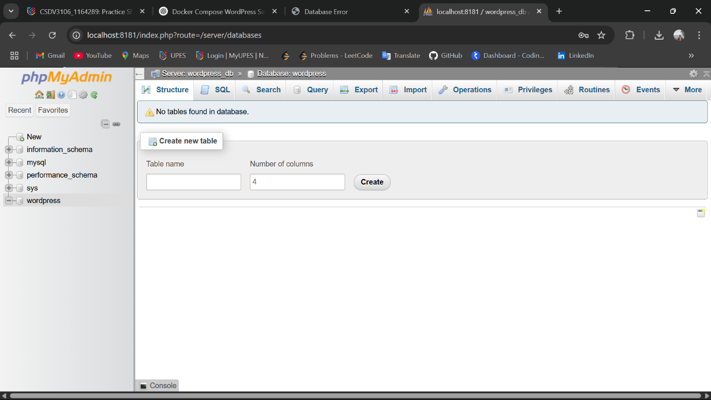
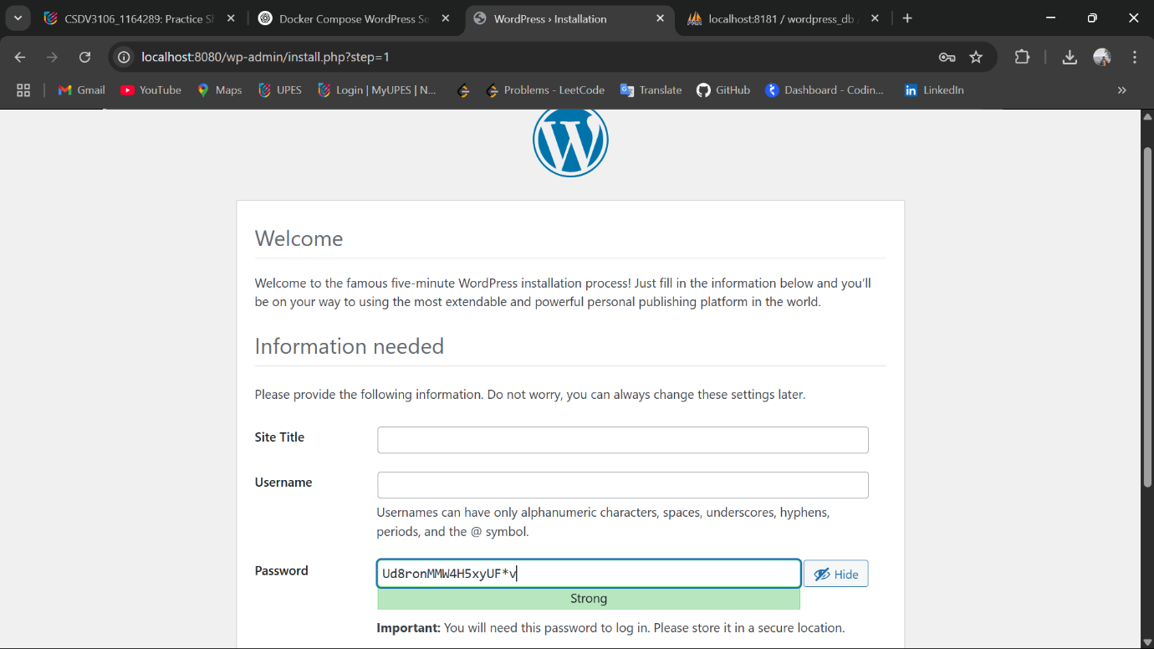

- Verify the Setup and cleanup
